Factors Impacting Users’ Adoption of Cloud Computing in Saudi Arabia
Student
University
Professor

Table of Contents
Introduction 4
Theoretical background and framework 8
Literature Review 9
Other Theories 13
Comparing Technology Acceptance Models (Tam), Theory Of Reasoned Action (TRA) And Theory Of Planned Behaviour (TPB) 21
Comparing Technology Acceptance Models (Tam), TAM2, TAM3 and UTAUT 22
Cloud computing over Traditional IT 23
Relative Advantages 23
Disadvantages of Cloud Computing 26
Challenge of Adoption 27
Cloud computing In Perspective 31
Cloud computing Deployment Models Explained 33
Key Characteristics of Cloud Computing 36
PART II 39
Research model and hypotheses 39
Attitude (ATT) 39
Perceived usefulness (PU) 40
Perceived ease of use 42
Trust 44
Perceived security 45
Perceived privacy 47
Subjective norm 47
PART III 49
RESEARCH METHOD 49
Questionnaire: 49
Technical Analysis 51
Results 52
Findings and Analysis 59
General Findings 59
Specific Findings 61
Recommendation 62
Conclusion 63
References 65

Factors Impacting Users’ Adoption of Cloud Computing in Saudi Arabia

Introduction
Cloud computing is one of the exemplary innovations in Information Technology that allows cloud service providers to host cloud-services users and also resources that are cloud-based in their service industries. Cloud computing offers some services including Infrastructure as a service and Software as a service. To begin with, platform as a service, are often integrated inside IaaS by experts to provide the magnitude as well as the distribution of any application. It also assists in predicting a company’s expense. Platform as a Service, ha a wide range of benefits including the fact that one can start an application with little financing and requires the basic development only. Also, the design of the service provides room for a lot of scalabilities as it is based on cloud computing. Infrastructure as service (IaasS, allows access to vital web infrastructure by business organizations, the various infrastructure services includes servers, connections and storage space. For businesses using this kind of infrastructure, the economies of specialization and scale are beneficial to the managed service provider. Software as a Service (SaaS), allows for the extension of the clouds for software infrastructure. Thus this helps contain the burden of support; the computer executes maintenance as well as operations as the functions performed by the applications, which are owned by the vendor.
The ability to provide room for scalability allows for flexibility. The implication here is that if one needs increases, it is easy to scale up the cloud capacity. On the other hand also one may want to operate on a relatively smaller scale and scaling down is provided, and thus the flexibility is integrated into the services. It also prevents a loss that might be brought about due to data loss. It provides a robust recovery with the cloud-based backup. Therefore, organizations can save time and resources as one is not required to hire a third part of recovery.
Cloud computing will be one of the best utilities in coming years due to its numerous advantages.
The reason behind its massive wide acclaim is due to its benefits that individuals get from using the technology. With increasing rates of cyber-attacks, this technology (cloud accounting) can store the information in the cloud and therefore not on computers physically. Therefore, this ensures that the information is safe from cyber-attack. This is so because cyber-attacks involve bypassing computer passwords and since the information is not stored in computers then the information will not be accessed. Therefore, in this way individuals can use the technology without fears of a security breach.
The theories that affect individual's adoption to technology include the theory of reasoned action (TRA) (Fishbein & Ajzen, 1975); the theory of planned behavior (TPB) (Ajzen, 1991); the technology acceptance model (TAM) (Davis, 1989); and the unified theory of acceptance and use of technology (UTAUT) (Venkatesh, Morris, Davis, & Davis, 2003). In relation to the adoption of any technological innovation and this case the cloud computing, this theory plays a role in influencing individual decisions and not the roles played by environment or organization.
The diffusion and adoption of cloud computing particularly among organizations is empowered through the general population accessibility of cloud computing (Optiz et al, 2012) that give different advantages like expanded adaptability and readiness (Weinhardt et al, 2009)
Despite the fact that cloud computing offers different open doors, the mentality towards cloud computing is impacted by various components going about as drivers and hindrances for its adoption. In this way, the gathering of rivals of this development is likewise still critical.
Being a critical zone for IT innovation and business venture (Low et al, 2011), the adoption of cloud computing has gotten expanding consideration in both practice and research. Albeit late examinations have given data on the current condition of the adoption of cloud computing, look into on drivers and boundaries of the wide organizational selection is still in beginning periods. Thus, there is as yet a need to think about both the behaviour towards selection and the genuine use of certain cloud application writes among organizations of various sizes, enterprises and additionally nations. To fill this need a re-evaluation of affecting variables with a unique concentrate on the setting of cloud computing is expected to give proper develops to operationalization in Saudi Arabia.
The objective of this paper is to give a reconceptualization and operationalization of imperative elements for cloud selection in organizational innovation. The elements must be hypothetically based and give a handy pertinence to the setting of cloud computing.
The most broadly utilized meaning of Cloud computing is:
A model for empowering advantageous, on-request network access to a common pool of configurable computing resources such as servers, applications, storage, applications, network and services that can be furnished rapidly and discharged with negligible administration exertion or specialist co-op cooperation" (Peter and Tim 2010).
Another definition is that:
It fundamentally alludes to the conveyance of data innovation (IT), including programming, by means of the general population web or private systems in view of Web guidelines" (Mark 2012).
By 2007, the term cloud computing was a famous method for portraying the internet based sparing of information and was bolstered with the expanded utilization of the internet in 2007. From that point forward, the buy or rental of servers and other PC gear started to be completed entirely on the premise of the variable request that organizations anticipated that concurring would their requirements (Regalado 2011). The US National Institute for Standard and Technology (NIST) has built up a meaning of cloud computing which is presently acknowledged by all divisions of data technology and which focuses on the specialized viewpoints concerning step-wise and web based datacentres of cloud computing. This definition is that the reason for cloud computing is to give proper access to a wide range of computer gadgets and services which incorporate software, storage, system and servers around the world without having any intercession from the specialist co-op side or from the side of management of the organization" (Peter and Tim 2010).
In this definition, the part of cloud computing as a stage is featured while the part of utilizations being run over this stage is not given much significance.
In any case, another definition, for example, that given by Boss et al. (2007) doesn't belittle the significance of the applications and gives approach noticeable quality to both the stage and applications. As indicated by Boss et al. (2007), the undertaking of a cloud computing stage incorporates de-provisioning, reconfiguration, arrangement, and changing arrangement of servers as required, which helps with running applications in a stage insightful way with enormous datacentres. The internet is utilized to host and utilize the applications since its servers on web are capable. This definition additionally underlines the essentialness of the terminals through which applications can be gotten to by means of the internet. These incorporate cell phones, tablets, and portable workstations, PCs and every single other sort of processing gadgets. Other shrewd gadgets are additionally connected to the cloud through the internet. One case of such shrewd gadgets is espresso producers that report blames specifically to the cloud through the internet (Pritchard 2012).

Theoretical background and framework
The Technology Acceptance Model (TAM) developed by Davis was proposed in 1986 to address the question regarding why users accept or reject information technology. The model was derived from the Theory of Reasoned Action, developed by Fishbein and Ajzen (Fishbein , Ajzen . 1975).
TAM was originally proposed by Davis (1989) for explaining the link between the actual use of the new technology and the behavioral intention (BI) of the individual to use the technology and is partly based on TRA. TAM posits that perceived usefulness (PU) and perceived ease of use (PEOU) are the fundamental determinants of the attitude towards the acceptance of new technology. TAM has been employed to investigate the adoption of new technologies in a range of domains including e-learning (Singh & Hardaker, 2014), internet banking (Sharma, Govindaluri, & AlBalushi, 2015), mobile learning (Tan, Ooi, Sim, & Phusavat, 2012), and social networking (Shin, 2010; Sharma et al., 2016). With regard to cloud computing, some studies can be found in the literature that employ TAM to model the technology acceptance by individual users for personal purposes. For example, Behrend et al. (2011) proposed an extension of TAM to identify factors determining successful acceptance of a cloud computing initiative in a community college. Another study on the adoption of cloud computing services by undergraduate students in a university setting was conducted by Park and Kim (2014).

Literature Review
The Technological Acceptance model (TAM) is one of the most significant theories of technology adoption, and it has proven to be satisfactory due to its nature of being highly predictive (Lee,2003). Davis primarily brought the model forward in 1986. The model was developed to predict the acceptance of individuals on the use of technology, and there are two believes that affect individuals in adopting technology inventions, that is Perceived usefulness and Perceived ease of use (Davis, 1989). According to Barua, it is believed that when the user accepts the use of a particular technology the usefulness, in turn, will be influenced by two factors, cost, and productivity (Barua, 1995). TAM has been proposed to be satisfactory in explaining technological adoption in Saudi Arabia (Alharbi, 2012). There are some factors that have been proposed in some studies; these factors included trust, anxiety and perceived risks (Nyoni & Piderit, 2012; Wu, 2013). Individuals in Saudi Arabia tend to possess anxiety that negatively influence the adoption of technology. Therefore, they tend to wait for others to test the perceived benefits of the technology to try it out. This is so because anxiety negatively influences the Perceived Usefulness of cloud computing. Anxiety hinders the adoption of cloud computing but when presented with the antecedents of trust (Udoh, 2012).
Technology Acceptance Model is a standout amongst the most mainstream theories that is utilized broadly to clarify Information System utilization. Such a significant number of studies have been led which has prompted the adjustments in the initially proposed demonstrate. Another model called joined TAM‐TPB demonstrate which incorporated the Technology acceptance model and theory of planned behaviour was proposed by Taylor and Todd(1995). Venkatesh and Davis(2000) proposed another form of TAM called TAM2 which added new factors to the current model. Venkatesh et al.(2003) in an examination distributed in MIS quarterly proposed the Unified Theory of Acceptance and Use of Technology(UTAUT) Model.
The different studies directed by experts have endeavored to change the TAM by adding new factors to it. Agarwal and Prasad (1998a, 1998b) adjusted TAM by including the build of compatibility in the Technology Acceptance Model. Moon and Kim(2001) has included another variable liveliness elements to consider acknowledgment of the internet. Lim(2000) proposed to change TAM by including factors like understanding, self-viability, perceived hazard and social impact. Another study done by Agarwal and Karahanna included psychological retention, fun loving nature and self‐efficacy to the TAM display. Chau(1996) in an examination looked into TAM by included two kinds of perceived usefulness: near‐term and long‐term. Van der Heijden(2000) in the wake of investigating the individual acknowledgment and utilization of the site added two new develops to TAM :perceived diversion value and perceived introduction appeal.
Chau and Hu (2002) joined the factor of associate Influence with Technology Acceptance Model. As indicated by examine by Franco and Roldan (2005) the connection between perceived usefulness and behavioral goal was solid among goal‐directed clients. Chau and Hu (2001) analyzed three models Technology Acceptance Model (TAM), the Theory of Planned Behavior (TPB), and a decayed TPB show that is conceivably sufficient in the focused on human services proficient setting in Hong Kong. The outcomes demonstrated that TAM was better than TPB in disclosing the doctors' aim to utilize telemedicine technology. The study directed by Sun and Zhang(2003) discovered intentionality can be factor in deciding the behavioral goal to utilize.
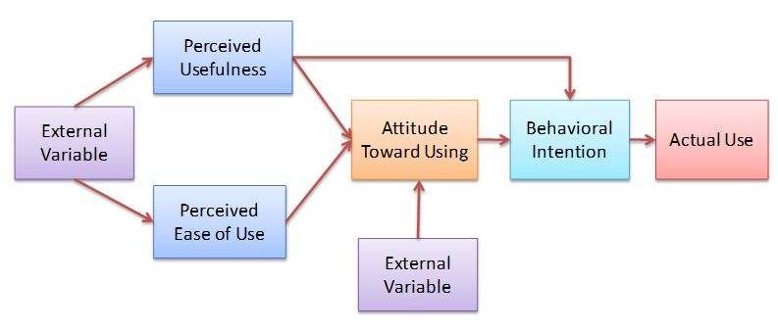
Fig 1: Technological Acceptance Model (TAM), Davis (1989)
TAM gives off an impression of being ready to represent 40 percent to 50 percent of customer acceptance. Cap has developed after some time.
TAM2 stretched out the first model to clarify apparent usefulness and utilization expectations including social impact (qualitative standard, intentionality, and image), intellectual instrumental procedures (work pertinence, yield quality, and result evidence) and experience. The new model was tried in both willful and required settings. The outcomes emphatically upheld TAM2 and clarified 60 percent of client selection utilizing this refreshed form of TAM (Venkatesh and Davis, 2000). This study embraced TAM2 as the pattern demonstrate notwithstanding TAM.
After conducting a structural equation modelling condition demonstrating procedure with LISREL, they inferred that system qualities were vital determinants to apparent usefulness, perceived ease of use, and utilization of an e-learning framework, and that the hypothetical model in light of TAM was all around bolstered. Saadé, Nebebe, and Tan (2007) additionally demanded that college students' interest and inclusion were vital to effective e-learning frameworks and accordingly students' acknowledgment behaviour ought to be evaluated. They recommended that TAM was a strong hypothetical model where its legitimacy can reach out to the sight and sound and e-learning setting.
Venkatesh and Davis (1996) concentrated on understanding the forerunners of the apparent usability. They reasoned that PC self-adequacy goes about as a determinant of perceived ease of use both prior and then afterward hands-on utilize and that the target ease of use was observed to be a determinant of usability simply after direct involvement with a framework.
As recommended in TAM2, qualitative standard, one of the social impact factors, alludes to the apparent social strain to perform or not to play out the behaviour. It appears to be vital to decide how social impacts influence the dedication of the client toward utilization of the data system for comprehension, clarifying, and foreseeing system use and acknowledgment behaviour (Malhotra and Galletta, 1999). As indicated by the study done by Gradon, Alshare, and Kwan (2005), qualitative standard was observed to be a critical factor in influencing college students' expectation to utilize e-learning. Interestingly, the examination done by Ndubisi (2006) demonstrated that qualitative standard had no noteworthy impact on college students' expectation to utilize e-learning. This sort of irregularity might be settled through the auxiliary condition demonstrating (SEM), which shows spurious impacts and roundabout impacts and direct impacts.
When all is said in done, factors identified with the behavioral aim to utilize data technology or to the genuine utilization of data technology could be assembled into four classes: singular setting, system setting, social setting, and organizational setting. While social setting implies social impact on individual acknowledgment of data technology utilize, organizational setting underscores any organization's impact or support on one's data technology utilize.
Thong, Hong, and Tam (2002) distinguished significance, system visibility, and system openness as organizational setting factors. They announced that the organizational setting influences both perceived value and perceived ease of use of a computerized library. Lin and Lu (2000) likewise announced that higher data readiness realizes higher utilization of data and higher view of ease of use. In this examination, e-learning readiness alludes to the level of straightforwardness with which a college student can access and utilize a grounds e-learning system as an organizational factor.
TAM is valid, robust, and most overwhelming and particular in concentrate organizational level adoption (Gangwar et al., 2014) in light of the fact that its proposed bland variables give more significant focal points into concentrate clients' feelings about particular frameworks, client appropriation procedures, and execution; the anticipating challenges; the technology's effect on value chain and post-selection dissemination; and the innovation of organizational capacities utilizing the technology.

Other Theories
Various theories have proposed to clarify customers' acknowledgment of new innovations and their expectation to utilize. These included, yet were not limited to, the Theory of Diffusion of Technologies (DIT) (Rogers, 1995) that began in 1960, the Theory of Task-technology fit (TTF) (Goodhue, and Thompson, 1995), the Theory of Reasonable Action (TRA) (Fishbein and Ajzen, 1975), Theory of Planned Behavior (TPB) (Ajzen, 1985, 1991), Decomposed Theory of Planned Behavior, (Taylor and Todd, 1995), the Technology Acceptance Model (TAM) (Davis, Bogozzi and Warshaw, 1989), Final form of Technology Acceptance Model (TAM) Venkatesh and Davis (1996), Technology Acceptance Model 2 (TAM2) Venkatesh and Davis (2000), Unified Theory of Acceptance and Use of Technology (UTAUT), Venkatesh, Morris, Davis and Davis (2003) and Technology Acceptance Model 3 (TAM3) Venkatesh and Bala (2008).
Rogers (1995) suggested that the theory of 'dissemination of development' was to build up the establishment for leading exploration on innovation acknowledgment and adoption. Rogers integrated research from more than 508 dissemination thinks about and turned out with the 'diffusion of development' theory for the appropriation of innovations among people and organization. The theory explains "the procedure by which an innovation is conveyed through specific channels after some time among the individuals from a social framework" (Rogers, 1995, p. 5).
Fundamentally, it's the procedure of the individuals from a social system imparted a development through specific channels after some time known as dissemination. The Rogers' (1995) diffusion of innovation theory clarified that the development and selection occurred subsequent to experiencing a few phases including understanding, influence, choice, execution, and affirmation that prompted the improvement of Rogers (1995) S-formed appropriation bend of trailblazers, early adopters, early larger part, late lion's share and laggards.

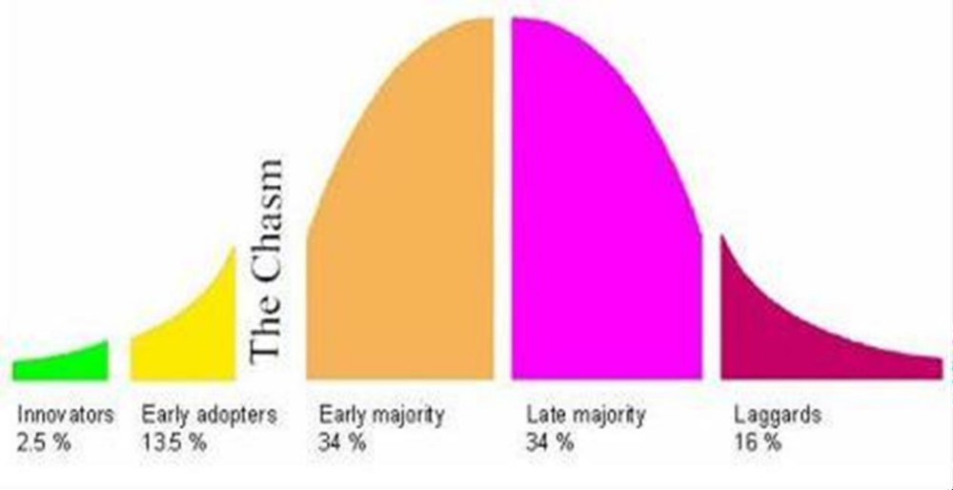
Figure 2. Development Adoption Curve (Roger, 1995)
Technology readiness (TR) alludes to individuals' affinity to grasp and utilization of new advances for fulfilling objectives in home life and at work (Parasuraman and Colby, 2001). In view of person's technology readiness score and the technology preparation, Parasuraman and Colby (2001) additionally ordered technology buyers into five technology status portions of wayfarers, pioneers, cynics, paranoids, and slouches. This is like Rogers (1995) S-formed appropriation bend of pioneers, early adopters, early greater part, late dominant part and slouches. The Diffusion of development or Technology readiness is imperative for organization usage achievement since it is showcase center.

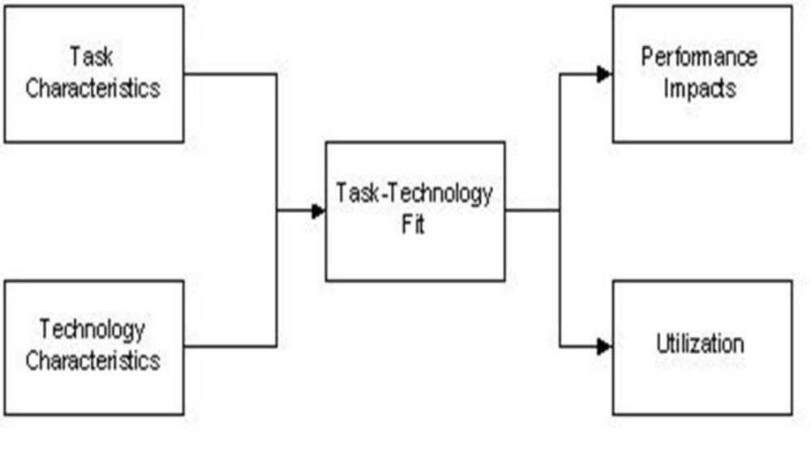
Figure 3. Errand technology fit (Goodhue and Thompson, 1995)
As indicated by Goodhue et al. (1995), Task-technology Fit (TTF) underscores singular effect. Singular effect alludes to enhanced proficiency, viability, or potentially higher quality. Goodhue et al. (1995) expected that the solid match amongst undertaking and technology is to improve the probability of usage and furthermore to expand the execution affect since the technology meets the assignment needs and needs of clients all the more nearly. As appeared in Figure 2, this model is reasonable for examining the genuine use of the technology particularly testing of new technology to get criticism. The undertaking technology fit is useful for measuring the technology applications as of now discharge in the commercial center like in the google play store or apple store application (iTunes) and so forth.
The Theory of Reasonable Action (Fishbein and Ajzen, 1975) is a standout amongst the most mainstream theories utilized and is around one factor that decides behavioral goal of the individual's mentalities toward that behaviour as appeared in Figure 3. Fishbien and Ajzen (1975) characterized "state of mind" as the person's assessment of a protest and characterized "conviction" as a connection between a question and some quality, and characterized "behaviour" therefore or expectation. States of mind are emotional and in light of an arrangement of convictions about the question of behaviour (e.g: Credit card is advantageous). A moment factor is the individual's qualitative standards of what they see their quick community's disposition to certain behaviour (e.g: my companions are utilizing Visa and it's a status to have one).
Decomposed Theory of Planned Behavior (Decomposed TPB) was presented by Taylor and Todd (1995). The Decomposed TPB comprises of three principle factors affecting behaviour goal and real behaviour appropriation which are state of mind, qualitative standards and perceived behaviour control. Shih and Fang (2004) analysed the selection of web keeping money by methods for the TPB and Decomposed TPB.
There has been a lot of research on the Theory of Reasoned Action (Ajzen and Fishbein, 1980; Sheppard, Hartwick, and Warshaw, 1988) Theory of Planned Behavior (Ajzen, 1991) and Decomposed Theory of Planned Behavior, (Taylor and Todd, 1995) however for the most part utilized for items as of now in the commercial center and incorporated the perspective of society (Qualitative standard).
Technology Acceptance Model (TAM) was presented by Fred Davis in 1986 for his doctorate proposition as appeared in Figure 5. An adjustment of Theory of Reasonable Action, TAM is particularly custom fitted for displaying clients' acknowledgment of data frameworks or advances.
Ajzen (1991) created Theory of Planned Behavior which is around one factor that decides behavioral expectation of the individual's states of mind toward that behaviour as appeared in Figure 4. The initial two components are the same as Theory of Reasonable Action (Fishbein and Ajzen, 1975). The third factor that is known as the apparent control behaviour is the control which clients see that may restrict their behaviour (e.g: Can I apply for the charge card and what are the prerequisites?).

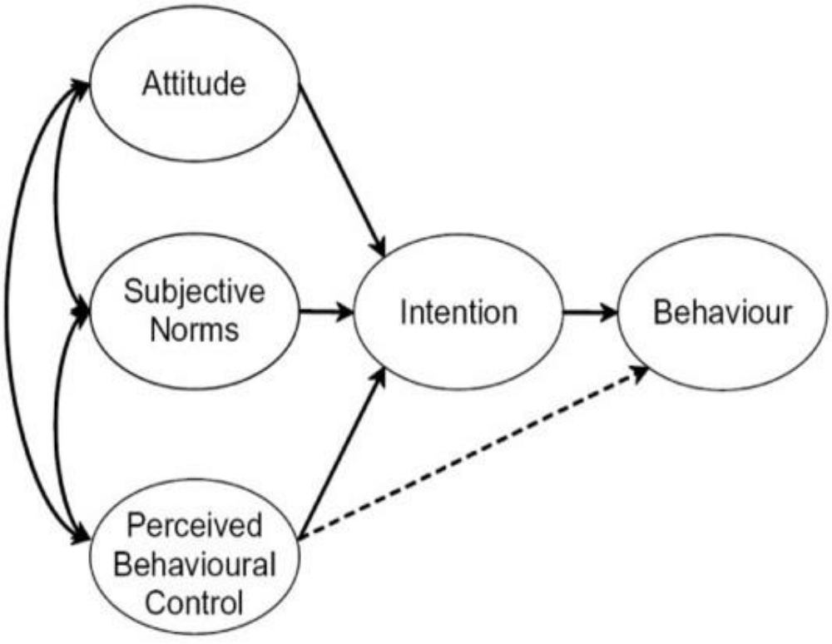
Figure 4. The Theory of Planned Behavior (Ajzen, 1991)
Venkatesh and Davis (2000) proposed the TAM 2 as appeared in Figure 8. This examination provided more detail clarifications to the reasons clients found a given system usefulness at three (3) focuses in time: pre-execution, one month post-usage and three month post-usage. TAM2 hypothesizes that clients' mental appraisal of the match between vital objectives at work and the outcomes of performing work errands utilizing the systemfills in as a reason for shaping observations with respect to the usefulness of the system(Venkatesh and Davis, 2000). The outcomes uncovered that TAM 2 performed well in both deliberate and obligatory condition.
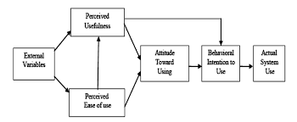
Figure 5. Technology Acceptance Model (TAM 2) (Venkatesh and Davis, 2000).
Incorporated model of technology acceptance (TAM3)
Venkatesh and Bala (2008) joined TAM2 (Venkatesh and Davis, 2000) and the model of the determinants of perceived ease of use (Venkatesh, 2000), and built up an incorporated model of technology acceptance known as TAM3. The creators built up the TAM3 utilizing the four distinct composes including the individual contrasts, systemqualities, social impact, and encouraging conditions which are determinants of perceived usefulness and perceived ease of use. In TAM3 look into display, the apparent usability to apparent usefulness, PC tension to apparent ease of use and perceived ease of use to behavioral expectation were directed by encounters. The TAM3 explore demonstrate was tried in true settings of IT usage.
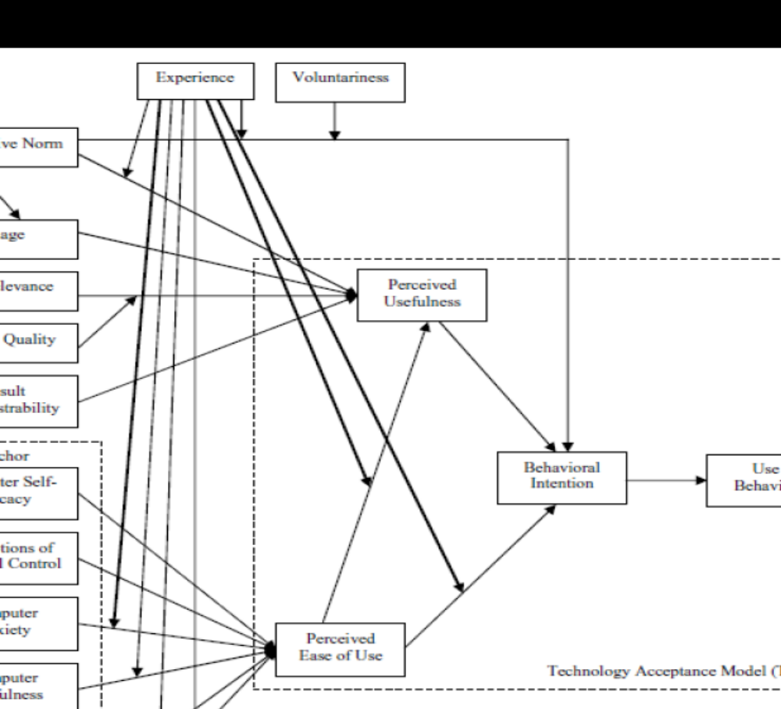
Figure 6. Technology Acceptance Model (TAM 3) (Venkatesh and Bala, 2008).

Comparing Technology Acceptance Models (Tam), Theory Of Reasoned Action (TRA) And Theory Of Planned Behaviour (TPB)
Davis, Bagozzi and Warshaw's (1989) think about analyzed the Technology Acceptance Model (TAM) with Theory of Reasoned Action (TRA) and brought about the union of TAM and TRA. This prompted a model in light of the three hypothetical determinants which are the apparent handiness, perceived ease of use and behaviour goal. The study discovered social standards (SN) as an imperative determinant of behaviour expectation to be feeble. Cap does exclude social standards (SN) as a determinant of behaviour goal (BI), which is a critical determinant, guessed by Theory of Reasoned Action TRA and Theory of Planned Behavior (TPB).
Mathieson (1991) contended that human and social elements could assume a part in the appropriation of technology utilizing TPB display. In this manner, the TAM could be reached out with builds from the TPB to fuse the social factors that could clarify technology selection. By the by, the TPB in Chau and Hu (2002) noticed that social standard and behaviour aim to utilize finding was negative and did not bolster that social standard would impact behaviour goal. Shih and Fang (2004) additionally inspected the adoption of web managing an account by methods for the TPB and in addition Decomposed TPB and found that it was in accordance with the findings of Venkatesh and Davis (2000) that qualitative standard was probably going to impact behavioral expectation to use in a required domain, while the impact could be immaterial in an intentional situation.
Davis, Bagozzi and Warshaw (1989) clarified that social standards scales had an extremely poor psychometric stance, and won't not apply any effect on customers' behaviour goal, particularly when the data systemapplication like single stage E-installment System was genuinely individual while singular use was deliberate. Consequently, the examinations of the study affirmed that Technology Acceptance Model was anything but difficult to apply crosswise over various research settings. Han (2003) and additionally Lai and Zainal (2014; 2015) noticed that utilizing TAM ability was good contrasted and TRA and TPB.

Comparing Technology Acceptance Models (Tam), TAM2, TAM3 and UTAUT
TAM2, an augmentation of the TAM was produced by Venkatesh and Davis (2000) because of the confinements of the TAM as far as informative power (R²). The yearning for the TAM2 was to keep the first TAM builds in place and "incorporate extra key determinants of TAM's apparent usefulness and use goal develops, and to see how the impact of these determinants changed with expanding clients' understanding after some time with the objective framework" (Venkatesh and Davis, 2000, p.187). Since TAM2 just centered around the determinants of TAM's apparent handiness and use aim builds, TAM3 by Venkatesh and Bala (2008) included the determinants of TAM's apparent ease of use and use goal develops for vigor. Subsequently, TAM3 introduced a total nomological system of the determinants of clients' Information Technology System selection (Venkatesh and Bala, 2008).
Venkatesh et al. (2003) consolidated four key determinants in the UTAUT demonstrate and there were execution hope, exertion anticipation, social impact and help conditions and four key mediators like sexual orientation, age, intentionality and experience. As indicated by Bagozzi (2007), UTAUT may be an intense model because of its niggardly structure and higher illustrative power (R²) however the model did not inspect coordinate impacts which may uncover new connections and in addition vital components from the examination which were forgotten by subsuming under the current indicators as it were. TAM2 and TAM3 likewise did not gauge and look at coordinate impacts which may uncover new connections and critical elements from the study.
Technology Acceptance Model (TAM2) by Venkatesh and Davis (2000), TAM3 by Venkatesh and Bala (2008) and UTAUT by Venkatesh, Morris, Davis and Davis (2003) were not chosen since the circumstance was for items to be executed in the commercial center and contemplated of qualitative standard that included society not required for this examination including the curiosity technology of single stage E-installment System. Davis, Bagozzi and Warshaw (1989) clarified that social standards scales had an exceptionally poor psychometric angle, and won't not apply any effect on buyers' behaviour expectation, particularly when data systemapplication like single stage E-installment System was genuinely individual while singular use was willful. UTAUT is an expansion from TAM2 and TAM3 is an augmentation of TAM2 that incorporates social impact, along these lines they won't be utilized as a part of this study in light of social standard.

Cloud computing over Traditional IT

Relative Advantages
The behaviour towards cloud computing is affected by different components going about as drivers and boundaries for its adoption. This part goes for reconceptualization and operationalization of generally acknowledged affecting elements on technology appropriation in connection to cloud computing.
The relative preferred standpoint factor starts from Rogers' DoI theory. Relative favorable position is characterized as "how much a development is seen as being superior to anything the thought it supersedes" (Rogers, 2003). With regards to data frameworks, the use of this theory uncovered that the relative preferred standpoint is a standout amongst the most critical variables for selection choices [34]. Cloud computing arrangements give a few relative focal points including load diminishing of the system framework, lessening of equipment upkeep and infrastructure operation, adaptability, straightforward organization, cooperation openings, potential cost investment funds, and expanded robotization (Stieninger, 2014).
Identified with cloud computing and SaaS in training, perceived ease of use was found to essentially affect fulfillment and impact convictions about the future utility of such frameworks. Seen value of cloud computing has additionally been investigated in extensive, publically exchanged ventures. Opitz et al. discovered that apparent handiness was a solid determinant of aim to utilize cloud Computing . Wu found that apparent handiness is a key achievement factor of SaaS selection inside Taiwanese technology organizations [(Wu, 2011)]. In any case, a few examinations have uncovered just a minimal effect of apparent handiness of SaaS on aim to receive [5] and furthermore dismissed apparent usefulness as an indicator of selection (Tjikongo, 2013). Besides, researching the utilization of frameworks after its adoption, a current report investigated post-acknowledgment technology duration and found that the effect of apparent usefulness on continuation of cloud computing was measurably critical and displayed one of the most astounding prescient values.
In view of existing writing there is an expansive gathering of things that must be inspected for the operationalization of the relative favourable position factor.
The talk above prompts the accompanying things to be considered for cloud computing:
Quality: Ideally, the execution of a specific cloud arrangement prompts the change of the nature of results contrasted with the arrangement it superseded. Sonnenwald et al. discovered that the nature of results is a marker for the relative favorable position (Sonnenwald et al, 2001).
Accommodation: Another imperative thing for the operationalization of the factor relative favorable position is the comfort provided by the received systemas expressed by Sonnenwald et al. (Sonnenwald et al, 2001).
Costs: Borgman et al. utilize the pointer costs as a thing to operationalize relative preferred standpoint by representing a potential lessening of general spending on IT. They found that cost diminishment prompts a higher relative preferred standpoint for adopters of cloud computing.
Speed: Low et al. express that relative preferred standpoint can be measured utilizing speed as thing speaking to speed of business correspondences, proficient coordination among firms, better client interchanges, and access to showcase data assembly [3].
Automation: cloud service providers handle the entire operation of hosting, keeping up, moving down information, reestablishing, observing, and giving specialized help.
Diminished Downtime: with cloud computing technology and having a control to deal with the administrations in view of interest of clients, the capacity of having the frameworks up and running is much conceivable. Cloud service providers handle the entire operation of hosting, keeping up, moving down information, reestablishing, checking, and giving specialized help.
Virtualisation: applying virtualisation technology creates various virtual machines on a solitary physical machine which can prompt decline the equipment and power costs.

Disadvantages of Cloud Computing
In spite of the many favourable circumstances, there are additionally weaknesses. There is almost certainly that there is much proof for cloud computing, however there may even now be issues, for example, server downtime, execution issues and IT development (Yang, 2012). Cloud computing administrations and web transmission capacity are firmly related, where keeping in mind the end goal to perform and give a productive administration, it is vital to have quick and predictable velocities since cloud computing utilizes the internet as its medium of information exchange. The UK Growth and Infrastructure Bill guarantees proficient, quick broadband systems crosswise over 90% of the UK by 2015 (Gov, UK, 2013). There is, all things considered, a peril postured by enabling one's computerized information to be held by outsiders. There have been accounted for occurrences of information robbery and loss of information. With the far reaching of informal community and Web 2.0, organizations, the utilization of cloud computing is likewise expanding. In addition, many feelings of trepidation and worries about the information proprietorship is moreover. Notwithstanding the approach utilized, it ought to be remembered that since the applications are controlled by outsiders, the clients have exceptionally restricted proprietorship and control over the product and equipment (Tsagklis, 2013).
Another real drawback of cloud computing is its dependence on the cloud specialist organization (Tsagklis, 2013). It is very difficult to move to another specialist organization. Wishing to do as such will prompt amazingly tiring and troublesome exchange of information volumes from one to the next. In this manner, the clients ought to deliberately vet their sellers previously settling on any choices (Tsagklis 2013).
Different genuine specialized burdens of cloud computing is downtime. It is conceivable to discover a cloud computing specialist organization, even the really best, would guarantee insurance to benefit interferences.

Challenge of Adoption
Compatibility
The compatibility factor is gotten from Rogers' DoI theory. "Compatibility is how much an innovation is seen as predictable with the current values, past encounters, and needs of potential adopters." (Rogers, 2003). As indicated by experts met amid an examination, cloud computing at times risks clashing with the set up organization reasoning (Stieninger, 2014). Tornatzky et al. characterize compatibility factor in a more operational manner as "consistency with the current practices of the adopters" (Tornatzky and Klein, 1982). Furthermore, Premkumar et al. recognize specialized compatibility and organizational compatibility.
This factor was decided for assist examination in light of the fact that, as indicated by Tornatzky et al., compatibility is the most much of the time referred to one. Armbrust et al. express, that today the greatest difficulties concerning this factor are process and information compatibility, in light of the fact that, because of absence of institutionalization, merchant changes can cause extra expenses for system relocation and combination. Subsequently, expanded compatibility impacts the adoption aim and the genuine appropriation of cloud computing decidedly.
Following the previously mentioned examinations, an operationalization of the factor compatibility should be possible by utilizing various things. As indicated by Premkumar, specialized and organizational perspectives must be incorporated.
In view of existing findings we distinguished the accompanying things as important to the compatibility factor with regards to cloud computing:
Information exchangeability: Borgman et al. recognized information exchangeability as an essential test on the specialized side It guarantees clients to effectively extricate their information from a cloud computing provider.
Process integrability: At the organizational level Borgman et al. distinguished process integrability as the most critical thing.
Vendor interoperability: Since missing institutionalization can cause secure impacts that keep clients from moving starting with one merchant then onto the next through extra expenses for movement and mix, seller interoperability encourages this by utilizing generally acknowledged models.
Cost: Price Value of Using Software and Platform
The connection between output and money related information is alluded to as cost viability. A huge advantage identified with the cost issue is the likelihood of paying on the premise of utilization as opposed to on any settled costs (Armbrust et al., 2009). Besides, the requirement for less space and lessened staff and support cost are further favourable circumstances since applications can be outsourced to the provider.
Cloud computing can supply a huge scale item asset requiring little to no effort, which is a basic ability. As indicated by (Armbrust et al., 2009), lessened expenses are increased because of various variables, which incorporate power, equipment and software, arrange costs and the system itself. The cloud provider, then again, can assess the profits as needs be (Armbrust et al., 2009). Calculation including a lot of information has turned out to be less demanding and more extensive with cloud computing, sparing both cash and time for client organizations. Parallel estimations are in this manner quicker in cloud computing when contrasted with private frameworks of figuring. This implies there is an immense distinction in time utilization. For instance, an occupation finished utilizing through cloud computing may take minutes or hours, while if a desktop system was utilized, it could take days or years. Along these lines, counts that used to be illogical are presently effectively reasonable in only a couple of minutes, with information exchange being speedier and faster than any time in recent memory.
There is a contention made by a few studies with respect to the shrouded costs causing the clients and customer's monetary weight, as they pay more than they anticipate. Consequently, the dread of further ascending of cost exists. This is a conceivable reason of the hesitance to embrace cloud computing. Venture made by the cloud computing is likewise observed as a boundary.
Lower costs benefits are one of the many favorable circumstances of cloud computing Cloud figuring encourages the utilization of processing assets as per require. Cloud computing is open from any gadget, for example, portable PCs, cell phones, tablets and subsequently is not gadget subordinate. It is not restricted to only a PC (Jackson, 2011). There are no settled expenses for cloud computing. Subsequently, less venture and lower dangers are related with it. The charges are made on the premise of utilization.
Agile Updating is another advantage of cloud computing. This permits the programmed refreshing of the system when the provider hosts any application with no planned downtime (Yang, 2012). As said before, cloud computing has low organization costs since no speculation is required at the underlying stages. Cloud computing is therefore extremely reasonable for ventures which are here and now. This is because of the way that there is no compelling reason to set up the entire framework, and clients can work straightforwardly on the venture (Yang, 2012), and the simplicity of incorporations and quick arrangement help in accomplishing this. Moreover, cloud computing likewise gives most extreme security to clients where they can utilize the assets from any locale whenever.
Since each cloud client is one of a kind, the potential reserve funds delivered by utilizing cloud computing administrations will contrast. Many components impact the aggregate cost of responsibility for IT infrastructure, for example,
Decreased Upfront Expenses: Reducing the forthright costs, such as working up another datacenter without any preparation and purchasing new gear, for example, (Servers, Firewalls, Rexternals, Switches, Data Storages, and so forth.) will assist the business pioneers with concentrating on the center business and spare the cash for genuine business openings.
Use based Pricing: in some cases organizations need to lead some product test, improvement, information examination, and other time-constrained preparing, in this manner, they simply need to pay for restricted servicers for some settled time.
For instance, a cloud computing end-client may require utilizing five servers to create and test a product through the span of fourteen days. Instead of buying the equipment and dispensing and energy to begin the transitory undertaking, you can essentially utilize five cloud-based servers remotely.

Indirect Benefits
The findings of the quantitative study in Chapter 5 demonstrated that aberrant advantages will have a noteworthy and positive effect on the appropriation of cloud computing by 99%. These advantages for the most part are hard to gauge, and incorporate the fulfilment, unwaveringness, inspiration, and other immaterial wonders. These advantages will urge the administration organization to embrace cloud computing. Senior administration and IT administrators comprehended the normal roundabout advantages that will take after from utilizing the cloud computing. Conversely, the IT masters were not all that mindful of these advantages. These findings mirror those in the writing, for example, in the examination of Kuan and Chau (2001) and Teo et al. (2009) that featured the roundabout advantages as a key persuading factor.

Cloud computing In Perspective
The current pattern in the cloud computing focus on the value being acquired by the clients by means of its administration infrastructure by specialist co-ops. In any case, the primary period of cloud computing bargains just with its administration assets, which incorporates the computerization of datacentres, the execution of systems, virtualization and other mechanical innovations (Boss et al. ,2007).
The essential idea of giving cloud computing through systems administration started in the 1960s preceding the internet had been included (Cafaro and Aloisio, 2011) and the administration arrangement of "PC utilities" through a system is just real help work. The arrangement of cloud computing through the Internet began in the 1980s with the assistance of Application Service Provision (ASP). Occasions of ASP additionally incorporate net-sourcing (Allen and Thomas, 2002), which focused on the outsourcing of computing administrations through the internet, however this was fleeting. Different cases, incorporate Hotmail, which in the 1990s outsourced administrations like email (Owens, 2010). With the old ASPs, it was difficult to outsource figuring practices and applications since they were moderate had lacking transfer speed (Thomas Kern et al., 2002). It ended up plainly less demanding to outsource computing and an application since the internet is bolstered by high data transfer capacities as an overall fiber-optic system, which has positive effects as decreased cost and better effectiveness (Hogendorn, 2011). Innovations like ware equipment virtualization "utility figuring" and "lattice computing" (Foster et al., 2008) brought about the likelihood of the arrangement of cloud computing on a colossal scale and this arrangement was converged with the expanded ability of systems administration as the internet and website stages.
A pattern from that point forward has been a change from computing utilizing singular PCs to datacentres which are produced by expansive public organizations as public databases which can be gotten to through the internet. Figuring with the assistance of these datacentres is alluded to as cloud computing. Some huge organizations, for example, Microsoft, Amazon and Google have created immense product datacentres (Boss et al, 2007).
Cloud computing (Carr, 2008) can likewise be viewed as a move from computing with singular PCs to the utilization of uses at the cloud (Cusumano, 2010) with the assistance of huge IT infrastructure (Cafaro and Aloisio, 2011). Positive and extremely idealistic remarks in regards to cloud computing have been made by industry investigators that this sort of computing will reform the figuring business sooner rather than later. Research by Merrill (Lynch, 2008) assessed a market chance of almost $ 160 billion. It additionally called attention to $95 billion and $65 billion in efficiency applications and online notice individually. Morgan Stanley investigate (Stanley, 2008) additionally affirms that cloud computing speaks to a huge pattern in the technology.

Cloud computing Deployment Models Explained
Cloud computing depends on a four kind of organizational progressive system. In one model, cloud offices are accessible to a gathering of people and organizations; every one of whom have a typical intrigue, and they get to a typical arrangement of utilizations and database. This incorporates organizations engaged with consistence, strategy, security prerequisites and mission. Here the figuring offices may be run and possessed by it is possible that at least one of the partners and may be physically present in a similar building.
Another model manages singular organizations and their workers or individuals, which get to the applications and datacentres of those specific organizations. The PCs included can likewise be available inside outside of organization's own structures and can be overseen by the organization itself or an outsider. Consequently, National Institute of Standards and Technology arranges cloud computing sending models as takes after (see Figure 6):
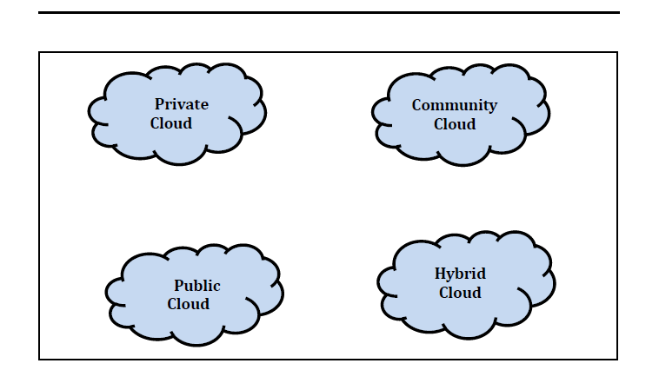
Figure 6: Cloud Computing Deployment Models (Peter and Tim 2010)
Private cloud: This cloud is intended to be utilized by an individual organization having different clients, for example, specialty units. The organization itself can lead the administration of the cloud PC, or it can be overseen by an outsider. It can be situated in or off the organization's premises.
Community cloud: This is intended for specific use for a specific community of clients that have similar concerns and needs, for example, security, strategy and mission. Administration and proprietorship can be of at least one organizations or by a keep running by an outsider.
Public cloud: This is intended for public utilize. Its possession and administration can be taken care of by some business organizations or government or scholarly organization. Consolidate an administration and proprietorship can likewise exist. Its offices must be situated in the premises of the cloud provider.
Hybrid cloud: This is a blend of at least two diverse cloud frameworks. It can be private, public or for community utilize. They have diverse unmistakable substances yet share a standard technology. This permits the movability of utilizations and information, for example, cloud blasting when stack is being adjusted between mists.
Cloud computing Service Model
Cloud computing can be classified into three administration models:
Infrastructure as a Service (IaaS): "The ability provided to the purchaser is to arrangement handling, stockpiling, systems, and other principal processing assets where the buyer can convey and run discretionary software, which can incorporate working frameworks and applications. The customer does not oversee or control the basic cloud system but rather has control over working frameworks, stockpiling, and conveyed applications; and potentially restricted control of select systems administration parts (e.g., host firewalls) (Peter and Tim 2010).
This permits the clients different figuring assets, for example, stockpiling, arrangement, preparing, or organizes. It gives the client a chance to run discretionary software, including working applications and frameworks. The client has full control of capacity and working frameworks. He likewise has a control over the uses of a specific point of confinement of control over the systems administration offices.
Platform as a Service (PaaS): The ability provided to the customer is to convey onto the cloud system buyer made or gained applications made utilizing software dialects, libraries, administrations, and instruments bolstered by the provider. The customer does not oversee or control the hidden cloud system including system, servers, working frameworks, or capacity, however has control over the conveyed applications and perhaps arrangement settings for the application-hosting condition (Peter and Tim 2010).
This enables the shopper to utilize the infrastructure of cloud, the applications particularly made for purchaser needs, and the software dialect and its instruments. Be that as it may, the purchaser can't utilize and deal with the principal framework, for example, the servers, systems, stockpiling or working frameworks.
Software as a Service (SaaS): The capacity provided to the purchaser is to send onto the cloud infrastructure consumer-created made or procured applications made utilizing programming languages, services, libraries, and devices bolstered by the provider. The consumer does not oversee or control the hidden cloud infrastructure including system, servers, working frameworks, or capacity, yet has control over the conveyed applications and perhaps arrangement settings for the application-hosting condition (Peter and Tim 2010).
This enables the client to utilize the applications that the provider has on the cloud framework. They can be gotten to utilizing distinctive customer gadgets or a web program, for example, an online email. The buyer in any case, has no entrance to the administration of the infrastructure, which incorporates servers, stockpiling, organizes and working frameworks.

Key Characteristics of Cloud Computing
Cloud computing is developing as an exceptionally powerful technology that guarantees a progressive future in the field of technology. It can direct and take into account an assortment of issues. The significant attributes of this kind of processing are as per the following (Reese, 2009; Rajkumar, 2009:
Scalability: Adding and dropping of hubs, including the servers from the system is conceivable. This enables a specific point of confinement to the progressions that can be made to the framework. In view of interest, its design can be scaled either vertically or on a level plane. A standout amongst the most imperative key normal for utilizing cloud computing is its versatility. Cloud computing permit gives the clients the capacity to effectively upscale or downscale your specialized necessities as required and required. For instance, cloud service providers enable you to deal with your necessities of existing IT assets to suit extended business needs. This would help you to help your business development without significant changes to your present frameworks.
Flexibility: Users are permitted to get to processing assets without the requirement for any human cooperation. Diverse capacities can be influenced accessible in quickly proportional to straightforwardly up or scale out relies upon the required administrations. Cloud computing enable clients to be more adaptable to accomplish their business errands. The clients of cloud computing can get to information anyplace and whenever. In the event that in the event that you are far from your office and need access to your information you can without much of a stretch interface with your virtual system.
Freedom: The client has practically zero control over the area of the provider giving him autonomy of area. He can, be that as it may, have a thought of the provider's nation or state.
Cost adequacy: Regardless of its sending model, cloud executions are tremendous, appreciating economies of scale. They are normally planned close power stations and shabby land, having lessened expenses. A few creators have demonstrated the reduction of capital costs as a key monetary pick up of cloud computing. The compensation as-you-go model, adaptability and versatility and also the abnormal state of virtualization of cloud computing administrations empower the cloud client to dodge spending enormously into the ownership of their computing offices ahead of time. Capital consumption expenses can be distributed to and controlled working expenses of agreement in the figuring cloud (Linthicum, 2009).
Maintainability: This is picked up by utilizing better utilization of assets, more effective frameworks and carbon lack of bias. The cloud computing diminishes carbon discharges by limiting vitality IT requests. As indicated by the a few examinations, offsite servers have the capacity by 2020 to confine 85.7 million tons of carbon discharges. A Research led by Google suggested that organizations could spare around 60-85 for every penny on their vitality costs by swinging to a cloud computing world. The environmental result of these huge diminishments in vitality is crucial (Matthews, 2013).
Network Access: The system enables access to capacities used by and advanced through stages, for example, portable PCs, cell phones and PDAs. Access to assets in the cloud is open over numerous gadget sorts. It doesn't just cover the most widely recognized gadgets (tablets, Pc's, iPad's, and so forth.) yet in addition cell phones, and so forth. Since organize data transmission has developed, arrange access and versatility have likewise enhanced as needs be. Expansive system access could be viewed as an essential empowering agent for cloud computing.
Preoccupied framework: The correct area and kind of the server which is facilitated applications is obscure, yet the specialist co-op gives clients the expected measurements to assess the acknowledged execution.

PART II

Research model and hypotheses
To frame a thorough image it is important to consider a few variables of development all the while and to assess their connections (Tornatzky and Klein, 1982). For instance Holland and Light distinguished a few basic achievement factors from a bigger rundown of elements found in important research [10]. The development factors that have the most reliably noteworthy connections to innovation appropriation are compatibility, relative preferred standpoint, and complexity (Tornatzky and Klein, 1982). These three variables begin from Rogers' Diffusion of Technology (DoI) theory, expressing that diffusion is "the procedure by which a development is imparted through specific channels after some time among the individuals from a social framework" (Rogers, 2003), though an innovation is "a thought, practice or protest that is seen as new by an individual or other unit of adoption" (Rogers, 2003). Compatibility, relative preferred standpoint and many-sided quality are seen traits of innovations that assistance to clarify the adoption of creative technologies and in this manner are thought to be significant with regards to this exploration. Notwithstanding the components expressed by Rogers' DoI, Moore and Benbasat considered the build image as a critical factor inside their innovation of an instrument to gauge the impression of embracing a data technology development.

Attitude (ATT)
Attitude towards using a new system is defined as an individual's overall affective reaction to use the system (Davis, 1989; Venkatesh et al., 2003). Students' positive feelings about mobile cloud storage services may positively affect their behavioral intentions.
There are some factors that have been proposed to affect individual adoption of technology, and this includes personal beliefs, attitudes, and intentions. There are some theories which have been brought forward to explain the individual adoption of technology, and this theory will be discussed in relation to believes and attitudes of individuals in Saudi Arabia.
Therefore, the following hypothesis is formulated:
H1: Attitude would positively affect user’s intentions to use cloud computing services.

Perceived usefulness (PU)
TAM posits that Perceived usefulness can be deﬁned as the degree to which a user believes that using mobile cloud storage services enhances his or her performance (Davis, 1989). Numerous studies (e.g., Joo and Sang, 2013; Park and Chen, 2007; Lee and Chung, 2009; Ha et al., 2007; Park and Kim, 2013) have replicated this TAM framework and demonstrated that perceived usefulness have positive effects on user attitude and behavioral intention. Therefore, the following hypotheses are proposed.
H2: Perceived usefulness would positively affect user’s attitudes toward using cloud computing services.
A few creators incorporate image inside the factor relative favorable position (e.g. (Rogers, 2003)). This has been condemned, as the impact of image is fairly unique in relation to the impact of relative preferred standpoint. Consequently, image ought to be determined as self-contained factor (Tornatzky and Klein, 1982).
To look at the adoption of mind boggling, new and intelligent technology it is advantageous to consider factors from more than one hypothetical model to express the multi-faceted nature of such a selection wonder. For this reason for existing Davis' Technology Acceptance Model (TAM) was incorporated into the examination. In that Davis examines two principle issues: To discover explanations behind clients to acknowledge or dismiss data technology and to cover the effect of configuration highlights of a system on customer acceptance. He researches causal relations between external jolt, psychological reaction, full of feeling reaction and behavioral reaction. The apparent value and perceived ease of use factors decide the psychological reactions to system configuration highlights. In any case, because of the reasonable closeness of perceived usefulness and perceived ease of use to relative favorable position and multifaceted nature (Moore, 1991), these two elements are specifically compelling with regards to cloud computing and in this manner are being talked about inside the segments of relative preferred standpoint and many-sided quality. Davis' TAM fundamentally goes for effects on the behaviour of people while this exploration concentrates on the organizational viewpoint. In any case, Benamati and Rajkumar expressed that numerous IT choices.
Moore and Benbasat express that there are clear likenesses between the builds of relative preferred standpoint (Rogers, DoI) and perceived usefulness (Davis, TAM) (Moore, 1991). Seen handiness has been characterized as "how much an individual trusts that utilizing a specific system would upgrade his or her activity execution.", and all the more as of late as "the value provided to the person by the technology" .This factor initially began in Davis' TAM and has been utilized as a part of many examinations investigating the adoption of data technology, including those exploring cloud computing.
As indicated by the first TAM, perceived usefulness is estimated to influence goal to utilize, and perceived ease of use is not guessed to specifically influence goal.
Usefulness: The favorable position provided by a cloud computing arrangement contrasted with a customary arrangement can be demonstrated by how much the achievement of assignments is bolstered by the arrangement (Sonnenwald et al, 2001).

Perceived ease of use
Perceived ease of use can be defined as the degree to which a student believes that using mobile cloud storage services is an effort-free behavior (Davis, 1989). Therefore, the following hypotheses are proposed.
H3: 3. Perceived ease of use would positively affect user’s attitudes toward using cloud computing services.
A few studies have inspected TAM as a model to clarify how individuals embrace and utilize e-learning. Selim (2003) expressed that there was a need to explore TAM with online learning. He set forward the course site acknowledgment demonstrate (CWAM) and tried the connections among perceived ease of use, perceived ease of use and goal to use with college students utilizing the basic condition displaying procedures of the LISREL program. He inferred that the model fit the gathered information and that the value and usability ended up being great determinants of the acknowledgment and utilization of a course site as a compelling and proficient learning technology. Seen handiness can be characterized as the degree to which a college student thinks utilizing e-learning will help his or her learning.
In the interim perceived ease of use is characterized as the degree to which one thinks utilizing e-learning will be free of psychological exertion. In this examination, e-learning alludes to unadulterated, electronic, non-concurring learning through an Internet webpage worked by the college. It is additionally upheld by the learning administration system(LMS) of the college Lee, Cheung, and Chen (2005) did comparative research with the LISREL program to explore college students' appropriation behaviour towards an Internet-based learning medium (ILM) presenting TAM, however they incorporated TAM with motivational theory. They included apparent delight as a characteristic helper notwithstanding perceived value and perceived ease of use into the TAM. As per their outcomes, perceived value and perceived delight affected the two students' behaviour toward and aim to utilize ILM.
Notwithstanding, perceived ease of use was observed to be random to disposition. In the interim, Liu, Liao, and Peng (2005) coordinated TAM with stream theory that stresses focus on the basic model. They contended that college e-learning system clients ought to be viewed as both system clients and students. Moreover, Liu, Liao, and Peng embraced e-learning introduction compose as an external variable into the model. They inferred that e-learning introduction write and clients' expectation to utilize elearning were identified with each other, and fixation and perceived usefulness were viewed as middle of the road factors. Pituch and Lee (2006) included system and student attributes as outside factors that were speculated to affect apparent usefulness, perceived ease of use, and utilization of an e-learning framework.
Grandon, Alshare, and Kwan (2005) demanded that e-learning self-adequacy was found to have roundabout impact on students' expectations through perceived ease of use. What's more, Mungania and Reio (2005) found a critical connection between dispositional boundaries and e-learning self-viability. They contended that instructive professionals should mull over the students' auras and discover routes through which e-learning self-viability could be made strides. In this study, e-learning self-viability is by and large spoken to as the individual trust in discovering data and speaking with a teacher inside the e-learning system and the important abilities for utilizing the framework.

Trust
Trust can be defined as User's confidence in the reliability and trustworthiness of the services offered by cloud service providers. Trust in a cloud environment depends on the privacy and security properties of the selected deployment model. Therefore, the following hypotheses are proposed.
H4: Trust would positively affect User’s attitudes toward using mobile cloud storage services.
As a writing review by Gefen et al. appears, there are a huge number of contrasting methodologies for the conceptualization of trust. Consequently, there are various trust protests and measures to operationalize the effect of trust on the appropriation of mechanical innovations. For this degree, the factor is considered as the capacity of the included performing artists to pass on the view of trustfulness (Stieninger, 2014).
Reliability: The repetition of locales permits the continuation of business movement on account of any fiasco. Dependability implies is the nature of being trustworthy. High unwavering quality is measured and anticipated with the base disappointment or administration downtime. This could be alluring to clients and organizations that depend on quick reactions and solid computing. System dependability is vital to make cloud computing effective.
Venkatesh et al. utilize execution hope as "how much an individual trusts that utilizing the system will push him or her to accomplish picks up in work execution" as a marker to operationalize relative favorable position.
In TAM, Davis portrays many-sided quality from a positive perspective and utilizations the term usability. He characterizes it as "how much an individual trusts that utilizing a specific system would be free of physical and mental exertion". Despite the fact that there are general contrasts between Rogers' DoI theory and Davis' TAM (i.e. Rogers concentrates on the organizational and Davis on the individual point of view, concerning many-sided quality and usability), they are both talking about the impression of people.

Perceived security
Perceived security refers to the degree to which students' belief that mobile cloud storage services are secure platforms for storing and sharing personal data. Service providers should ensure that their main security goals are confidentiality, integrity, and availability. Therefore, the following hypotheses are proposed.
H5: Perceived security would positively affect user’s trust in cloud computing services.
Security Concerns: The contextual study findings demonstrate that security concerns are the most critical issue which keeps government organizations from embracing cloud computing technology. This worry thought to be the most irritating test for organizations. The security concerns influence them to waver about moving to the cloud computing. Security is dependably the most noteworthy need for the administration organization, and they will never go for broke of it being traded off.
Then again, security concerns are being found in west uniquely in contrast to the Saudi setting in view of reasons identified with social and political issues. As specified over the political elements have an immediate effect of taking care of and managing the security concerns. In west, the managing the cloud security concerns could be overseen and managed by applying the condition of-workmanship strategies and devices to meet the security gauges.
Organizations who have fluctuating levels of interest for the figuring administrations as they don't need to pay so much and pay just when the need an administration. Clients are given productive help and adequate security. They are given an exhaustive learning of the subject and know about the strategies includes.
Cloud computing has some specialized hindrances, for example, requesting a nonstop web organization and consistent speed, unsuitable highlights, security won't not meet the organization gauges, risk of losing information (Miller, 2008, Jeffrey and Neidecker-Lutz, 2009).
Moreover, perceived security and wellbeing seem to affect confide in this unique situation. An examination of impacting factors for the acknowledgment of cloud computing among SMEs in Austria uncovered the significance of perceived security and wellbeing with regards to the adoption procedure (Stieninger, 2014). This develops features the current attitudinal contrasts concerning cloud computing among the groups of experts.
The supporters of cloud computing state that its appropriation adds to enhanced security, the adversaries censure protection administration and information security (Stieninger, 2014). As an experimental examination by Park and Ryoo uncovered, perceived security and wellbeing can go about as an empowering agent and an inhibitor inside a changing situation from ordinary IT to cloud computing (Park et al, 2013). Following Wu, inside this exploration perceived security and wellbeing were connected as a component of trust and consequently security and trust were consolidated to one factor [(Wu, 2011)].
In light of current writing we recognized the accompanying things as proper for the perationalization of the security and put stock in factor with regards to cloud computing: Information security: According to Stieninger and Nedbal, enhanced information security gauges assume an essential part for organizations in the appropriation choice procedure of cloud computing arrangements (Stieninger, 2014).

Perceived privacy
Perceived privacy refers to the degree to which students believe that mobile cloud storage services are safe and protects their sensitive data. When a student uses these services, there is a risk of recording or monitoring his/her personal data. Therefore, the following hypotheses are proposed.
H6: Perceived privacy would positively affect user’s trust in mobile cloud storage services.
It is believed that individuals in Saudi Arabia are reluctant into using the technology because they are not sure of their security, reliability, and privacy. The perceived risk entails the uncertainty and devastating consequences that in most cases usually affect the decision of consumers to adopt a certain technology (Dowling, 1986). Cloud computing raises privacy and security concerns among individuals (Albaroodi, 2014; Biswas and Biswas, 2004) and therefore the implication of adopting cloud computing involves uncertainty and risky situations.

Subjective norm
Social influence refers to salient social referents that lead individuals to behave or not to behave in a particular way (Fishbein & Ajzen, 1975: 302). Referents are people who are important to individuals, such as superiors (parents and teachers) or peers (friends and classmates). Individuals will be motivated to comply with referents even if they themselves do not favor the behavior in question (Taylor & Todd, 1995; Rogers, 1995; Venkatesh & Davis, 2000a, 2000b). However, the effects of subjective norms on intentions remain inconclusive: some evidence suggests the importance of the roles of subjective norms on technology usage (Taylor & Todd, 1995; Venkatesh & Bala, 2008; Venkatesh & Davis, 2000a). Some research findings suggest that subjective norms negatively influence technology adoption intention (Loraas & Wolfe, 2006), while other researchers find that the impacts are not significant (Venkatesh & Davis, 2000b; Venkatesh et al., 2003). It is possible that people subscribe to cloud services because of important referents.
Therefore, the following hypotheses are proposed.
H7: Subjective norm would positively affect user’s attitudes toward using mobile cloud storage services.

PART III

RESEARCH METHOD

Questionnaire:
Data for the study were collected through an individual survey using a structured self-administered questionnaire. The questionnaire was developed based on a conceptual model that was previously made by Yin (2003) in researches on titled Case study research: design and methods. Moreover, Data collected from the questionnaire varied among different scales. The questionnaire is designed in Arabic. Accordingly, respondents indicated whether they used cloud computing services or not. The questions were varying from evaluating various factors based on the importance of each one of them, to the measuring of users’ satisfaction towards cloud services.
I distributed the questionnaires using the social media approach of questionnaire distribution. 314 questionnaires were filled.
Survey method
The survey was distributed mainly among Riyadh citizens, since they form the majority of Saudi Arabia. Moreover, respondents from the target population were individuals, households and entrepreneurs. The total surveyed peopl is 314. The following methods were used for contacting the target audience (friends & family WhatsApp groups, private communication, Facebook post directed for peers). Google Documents was used as a method of data collection, were individuals receive a weblink and asked to fill in the questioner.

Sample
The study targeted Saudis and non-Saudis using cloud computing services. Those who did not have cloud services were excluded because the investigation was exclusively on cloud services users. A total of 187 usable completed questionnaires formed the basis for the data used in the analyses. The demographical variables of the respondents include gender, age group, education level and monthly income. Table1 shows demographical variables in frequency and percentage.
Variable | Value | Frequency | Valid Percent
Gender | Male | 151 | 80.75
Gender | Female  Blank | 34  2 | 18.18  1.07
Gender | Total | 187 | 100
Age Group | 18 years and less | 1 | 1
Age Group | 19 - 25 years | 17 | 9
Age Group | 26 - 35 years | 89 | 48
Age Group | 36 - 45 years | 64 | 34
Age Group | Over 56 years | 16 | 9
Age Group | Total | 187 | 100
Education level | High School or less | 13 | 7
Education level | Diploma | 18 | 10
Education level | Bachelor's degree | 89 | 48
Education level | Master's degree or more | 66 | 35
Education level | Blank  Total | 1  187 | 1  100
Occupation | Student | 29 | 16
Occupation | Employee | 117 | 63
Occupation | Retired | 16 | 9
Occupation | Other | 24 | 13
Occupation | Blank  Total | 1  187 | 1  100
Table 1: Social and Demographic factors

Table1 showed the percentages of each of the social and demographic factors. The rest of the percentage for each variable was those who did not answer that question. The sample represent 80.75% of the respondent are male and the female is only 18.18% of the whole sample. The majority of the sample about 48% of the sample aged between 26 – 35 years. Regarding the level of education 83% of the sample is between bachelor and master degree. For the job category 63% of the sample is employees.

Technical Analysis
Data collection tool used for this study was a structured self-administered questionnaire which was coded in Google Docs. service, likewise the data was extracted, and the analysis was conducted using the following techniques:
1. Descriptive statistics which were used to calculate the means, frequencies and standard deviation for scale and continuous data variables. Similarly, to calculate the frequencies and percentages for categorical data variables.
2.Inferential statistics which were used to detect the effect of independent variables such as demographic and social demographic variables on dependent variables such as satisfaction with cloud services for instance. Among the inferential statistical tolls was the one-way ANOVA test for comparing means which was conducted on scale and continuous variables while Chi Squire Test was to analyse categorical data variables where the p value tested the significant effect between dependent and independent variables.

Results
The first part of the questionnaire is concern about the sample understanding of the concept of cloud services and its functions, which was defined in the questionnaire.
Table2: The elements that were used in determining intentions to use cloud services
Users’ intention to use cloud computing services
 | N | Mean | Std. Deviation
I am willing to perform some of the current  computer tasks through cloud computing services | 187 | 3.52 | 1.24
I plan to use cloud computing services in the next  six months | 187 | 3.48 | 1.32
Note (mean=1: Strongly disagree, mean=5: Strongly agree) (Scale 1-5).
The study sample agrees that they intend to start using cloud services to perform some computer tasks (mean=3.52). Furthermore, they agree less in planning to use cloud computing services in the next six months (mean=3.48).

Table 3: Attitude towards cloud computing services
Below are statements about your attitude towards cloud computing services. Please indicate to what extent you agree or disagree with each statement by circling the appropriate number.
 | N | Mean | Std. Deviation
Using cloud computing services is a good idea | 187 | 4.01 | 1.08
I prefer to use cloud computing services | 187 | 3.79 | 1.22
Note (mean=1: Strongly disagree, mean=5: Strongly agree) (Scale 1-5).
The results showed that people agreed that using cloud computing services is a good idea (mean = 4.01) and people also agreed that they prefer to use cloud computing services (mean= 3.79).
Table 4: Perceived benefits of cloud computing services
Below are statements about the perceived benefits of cloud computing services. Please indicate to what extent you agree or disagree with each statement by circling the appropriate number.
 | N | Mean | Std. Deviation
Using cloud computing services improves my performance in my work (as a quality) | 187 | 3.79 | 1.09
The use of cloud computing in my work increases my productivity | 187 | 3.84 | 1.13
Cloud computing services are useful in use | 187 | 4.09 | 1.01
Note (mean=1: Strongly disagree, mean=5: Strongly agree) (Scale 1-5).
The results showed that people agreed that using cloud computing services improves performance and increase productivity (mean = 3.79 & 3.84) and people also agreed about the usefulness of using cloud computing services (mean= 4.09).
Table 5: Ease of use of cloud computing services
Below are statements about the ease of use of cloud computing services. Please indicate to what extent you agree or disagree with each statement by circling the appropriate number.
 | N | Mean | Std. Deviation
Interaction with cloud computing services does not require much effort | 187 | 3.81 | 1.06
I find cloud computing services easy to use | 187 | 3.78 | 1.07
It is easy to access cloud computing services to meet my practical needs | 187 | 3.79 | 1.08
Note (mean=1: Strongly disagree, mean=5: Strongly agree) (Scale 1-5).
The results showed that people agreed that interaction with cloud computing services does not require much effort (mean = 3.81) and people also agreed that using cloud computing services are easy to use and easy to access (mean= 3.78 & 3.79).
Table 6: Trust in cloud computing services and service provider
Below are statements about the perceived trust of cloud computing services and service providers. Please indicate to what extent you agree or disagree with each statement by circling the appropriate number.
 | N | Mean | Std. Deviation
Cloud computing providers are generally trustworthy | 187 | 3.61 | 1.06
I am confident that the cloud computing provider takes my concerns into account | 187 | 3.63 | 1.01
I am confident that the cloud provider is doing its job without having to monitor it from others. | 187 | 3.30 | 1.17
In general, I trust cloud computing | 187 | 3.58 | 1.07
Note (mean=1: Strongly disagree, mean=5: Strongly agree) (Scale 1-5).
The results showed that people agreed in trusting cloud computing services and its providers (mean = 3.61, 3.63, 3.58) and people are neutral about how confident they are that the cloud provider is doing its job without having to monitor it from others. (mean= 3.30).
Table 7: The perceived security of cloud computing services
Below are statements about the perceived security of cloud computing services. Please indicate to what extent you agree or disagree with each statement by circling the appropriate number.
 | N | Mean | Std. Deviation
I feel secure sharing my profile when using cloud computing | 187 | 3.26 | 1.25
I feel secure in storing my personal information in cloud computing services | 187 | 3.19 | 1.27
Note (mean=1: Strongly disagree, mean=5: Strongly agree) (Scale 1-5).
The results showed that people are neutral about feeling secure sharing their profile when using cloud computing (mean = 3.26) and people also neutral about feeling secure in storing their personal information in cloud computing services (mean= 3.19).

Table 8: The perceived privacy of cloud computing services
Below are statements about the perceived privacy of cloud computing services. Please indicate to what extent you agree or disagree with each statement by circling the appropriate number.
 | N | Mean | Std. Deviation
I am concerned that the use of cloud services allows service providers to gather a lot of information about me | 187 | 3.30 | 1.21
It bothers me when cloud service providers ask me for personal information. | 187 | 3.41 | 1.23
My personal information can be misused when using cloud computing services | 187 | 3.31 | 1.25
Note (mean=1: Strongly disagree, mean=5: Strongly agree) (Scale 1-5).
The results showed that people are neutral about their privacy when using cloud computing services (mean= 3.19).
Table 9: The impact of the environment on the use of cloud computing services
Below are statements about the impact of the environment on the use of cloud computing services. Please indicate to what extent you agree or disagree with each statement by circling the appropriate number.
 | N | Mean | Std. Deviation
People I know think I should use cloud computing services. | 187 | 3.19 | 1.11
People I know can provide support for the use of cloud computing services. | 187 | 3.24 | 1.11
Note (mean=1: Strongly disagree, mean=5: Strongly agree) (Scale 1-5).
The results showed that people are neutral when it comes to the effect of the people they know on their usage or in providing support for using cloud computing services (mean= 3.19, 3.24).
Table 10: Effect of price value (cost of using software and platform service)
Below are statements about the effect of price value (cost of using software and platform service). Please indicate to what extent you agree or disagree with each statement by circling the appropriate number.
 | N | Mean | Std. Deviation
Cloud computing services reduce our costs | 187 | 3.65 | 1.05
Using paid cloud computing services gives us a good solution for some tasks | 187 | 3.84 | 1.04
Note (mean=1: Strongly disagree, mean=5: Strongly agree) (Scale 1-5).
The results showed that people agreed that using cloud computing services reduce costs (mean = 3.65) and people also agreed that using paid cloud computing services gives them a good solution for some tasks (mean= 3.84).
Table11: The relationship between average daily use of internet and perceived usefulness
perceived usefulness
 | Mean | N | Std. Deviation
Less than 5 hours | 4.15 | 54 | 0.92
6 – 10 hours | 4.45 | 100 | 0.80
11 – 15 hours | 4.26 | 27 | 0.90
More than 16 hours | 4.67 | 6 | 0.82
Total | 4.38 | 187 | 0.86

Table12: Analysis of variance between average daily use of internet and perceived usefulness
ANOVA Table
 |  |  | Sum of Squares | df | Mean Square  Mean Square  Mean Square | F | Sig.
perceived usefulness * average daily  use of internet | Between Groups | (Combined) | 4.013 | 3 | 1.34 | 1.85 | 0.014
perceived usefulness * average daily  use of internet | Within Groups |  | 132.083 | 183 | 0.722
perceived usefulness * average daily  use of internet | Total |  | 136.096 | 186
Table 11 and 12 showed the relationship between the average daily use of internet and perceived usefulness. The results showed that the perceived usefulness was changing as increase in the average daily use of internet, those who uses more internet on daily bases were significantly perceiving the cloud computing as more useful p=0.014

Table13: The relationship between computer experience and ease of use of cloud services
computer experience
 | Mean | N | Std. Deviation
Level 1 | 3 | 3 | 2.00
Level 2 | 3.4 | 5 | 1.67
Level 3 | 3.74 | 69 | 0.92
Level 4 | 4.125 | 56 | 0.92
Level 5 | 4.72 | 25 | 0.46
Total | 3.8 | 158

Table14: Analysis of variance between computer experience and ease of use of cloud services
ANOVA Table
 |  |  | Sum of Squares | df | Mean Square  Mean Square | F | Sig.
ease of use * computer experience | Between Groups | (Combined) | 23.324 | 4 | 5.831 | 6.99 | 0.00003
ease of use * computer experience | Within Groups |  | 127.669 | 153 | 0.834
ease of use * computer experience | Total |  | 150.994 | 157
Table 13 and 14 showed the relationship between computer experience and ease of use of cloud services. The results showed that the ease of use was changing as increase in computer experience, those who has more computer experience were significantly easily using the cloud services (p=0.00003)
Discussion
This section will put focus on the above discussed factors and how they are influencing the adoption of cloud computing by user. It will further indicate what improvement is required.

Findings and Analysis

General Findings
Cloud computing in Saudi Arabia has not gotten much consideration (Yamin, 2013) and little research has been directed in concentrate the execution of Cloud Computing in the nation. For instance, Alharbi (2012) contemplated clients' acknowledgment of Cloud Computing in Saudi Arabia in view of Technology Acceptance Model (TAM). From an organization level, Yamin (2013) finished a review of Cloud Computing mindfulness in Saudi Arabia. The study demonstrated that Cloud technologies will be another pattern for Saudi's organizations. In any case, this examination provided a general perspective of Cloud Computing adoption in Saudi Arabia.
Alkhater et al (2014) explored compelling variables on the appropriation choice of Cloud Computing as a rule. They showed that many factors, for example, trust, relative favorable position; technology preparation will impact the utilization of Cloud Computing technology. Be that as it may, they didn't research the impact of two measurements that are human and business on the execution of Cloud Computing. Another confinement of their study is the specimen size of the examination which was little.
Tashkandi and Al-Jabri in (2015) examined Cloud Computing selection by advanced education organizations in Saudi Arabia. The examination concentrated on: innovative, organizational and ecological components. They found that relative favorable position has positive impact on the choice of Cloud Computing adoption. They additionally found that intricacy and seller secure have negative effect on the choice of Cloud Computing adoption. Their examination has a few constraints, for example, concentrating primarily on advanced education organizations and the analysts do excluding business measurement which is imperative measurement in the selection of Cloud Computing. Concentrate the adoption of Cloud Computing in Saudi Arabia as a rule (and in human services division specifically) needs more investigative endeavors (Yamin, 2013).
The examination of the information demonstrates that the majority of the administration organizations considered will bolster the adoption of cloud computing in spite of the fact that levels of help contrast. In view of the administration organizations comprise of regular citizen and military segments and every area demonstrated some unique concerns and issues. Individuals from regular citizen organizations displayed the energy about receiving cloud computing sooner rather than later than military ones. The senior chiefs comprehended the significance of receiving cloud computing and demonstrated an adequate level of mindfulness in such manner. It is seen that the staff of government organizations don't know will's identity in charge of the selection procedure in Saudi Arabia, and they are sitting tight for the suitable activities to originate from some place.
The individuals from the administration organizations demonstrated exceptionally solid enthusiasm for cloud computing; however despite everything they require more data about it and a superior attention to the significance of utilizing this technology. Likewise, it was seen that the IT directors met are the most energized towards the appropriation of cloud computing as they know about the advantages of utilizing it. In any case, the administration organizations in Saudi Arabia have been sitting tight for the decision specialist to give the vital summons to the administration pioneers to begin moving to cloud computing, as this how things work in Saudi Arabia in such cases. Singular activities are extremely constrained with such huge undertakings.

Specific Findings
Interview on attitude towards cloud computing services revealed that people agreed that using cloud computing services is a good idea (mean = 4.01) and people also agreed that they prefer to use cloud computing services (mean= 3.79).
The reasons for attitude towards the adoption of cloud computing were twofold, namely: a. that using cloud computing services was a good idea; and, b. that on a scale of 5, 3.79 interviewees preferred to use cloud computing services.
Perceived Usefulness: Based on the exact information, the ease of use of cloud computing is thought to be one of the highlights that would bolster government organizations in choosing to receive cloud computing. Its apparent usefulness would urge them to utilize data technology as a rule and cloud computing, specifically.
From analysis the results showed that people agreed that using cloud computing services improves performance and increase productivity (mean = 3.79 & 3.84) and people also agreed about the usefulness of using cloud computing services (mean= 4.09). The same was based on factor and acknowledgement that: a. using cloud computing services improved performance in interviewee’s work (as a quality); b. the use of cloud computing in interviewee’s work increased their productivity; and, c. cloud computing services were useful in use.
The findings from the interviews demonstrate that the usefulness of cloud computing drives the interviewees to wish to embrace this technology at the earliest opportunity.
On perceived ease of use of cloud computing services, results showed that people agreed that interaction with cloud computing services does not require much effort (mean = 3.81) and people also agreed that using cloud computing services are easy to use and easy to access (mean= 3.78 & 3.79). Further, at a mean of 3.81, interviewees agreed that interaction with cloud computing services did not require much effort.
As indicated by the above findings, the ease of use of cloud computing administrations is seen by all levels of staff in a wide range of organizations as a critical factor that would help them to receive this technology, and any troubles that could be overwhelmed by giving on-going preparing and specialized courses.

Recommendation
Security is an urgent factor for organizations in choosing to receive cloud computing, and it has the most astounding need. In addition, this worry could be overwhelmed by giving all important hardware and specialized and administration arrangement. The findings likewise demonstrate that security is seen diversely by each level of members and furthermore varies amongst military and civil organizations.
Particularly with respect to public cloud situations this factor is vital. As of now there is as yet an absence of certainty to cloud computing, most likely because of its curiosity. To support trust Buyya et al. propose giving customized SLAs for clients, discussing always with them and empowering input (Buvya et al, 2009).
Trustfulness of the cloud specialist organization: Wu (2011) found that trustfulness of cloud service providers is basic. Because of the negative notoriety and nonattendance of trust in the technology provider), it is imperative that a solid dependable relationship is created between specialist co-op of Cloud and its clients. Additionally, there is have to likewise feature the importance of a dependable connection between the specialist organization and the clients as a necessity while embracing Cloud Computing. Subsequently, it is prescribed to overcome any issues of data that exists between the two subjects.

Conclusion
Like prior studies (Lee, Cheung, and Chen, 2005; Saadé, Nebebe, and Tan, 2007), this examination affirmed TAM to be a valuable hypothetical model in comprehension and disclose behavioral goal to utilize e-learning. Consequences of the present research prompted the conclusion that the model all around spoke to the gathered information as per the aftereffect of integrity of-fit test.
System readiness as an organizational factor was not overwhelming exogenous build influencing all endogenous develop with the exception of perceived ease of use. Subsequently, it doesn't make a difference whether the college gives simple access to the student or not.
In this paper, it has been given a talk of pertinent elements affecting the expected and real use of cloud computing. The emphasis was on public cloud benefits in the organizational setting. The commitment and principle consequences of this examination target both research and practice.
In view of broadly acknowledged speculations, for example, Rogers' DoI theory and Davis' TAM this paper talks about, reconceptualises and operationalizes principle factors for use with regards to cloud computing. This gives a thorough premise to model and theory improvement.
Importantly, with the operationalization provided thus, the paper gives a fundamental premise to an experimental assessment of cloud computing and their present state inside the selection procedure. The consequences of such an assessment thusly may add to the upgrade of the view of cloud computing as a rule and in this way prompt a changed general impression of cloud computing which again quickens its diffusion.

References

Agarwal, R and Prasad J. (1998a), “A conceptual and operational definition of personal innovativeness in the domain of Information technology”, Information system research, Vol 9, No2, pp 204‐215
Agarwal, R., and Prasad, J. “A Conceptual and Operational Definition of Personal Innovativeness in the Domain of Information Technology,” Information Systems Research (9:2), 1998b, pp. 204‐215.
Ajzen, I. (1991). The Theory of Planned Behavior. Organization Behavior and Human Decision Processes, Academic Press, Inc. 179-211.
Alharbi ST (2012) Users’ acceptance of cloud computing in Saudi Arabia. Int J Cloud Appl Comput 2(2):1–11
Alharbi, S.T., 2012. Users' acceptance of cloud computing in Saudi Arabia: An extension of technology acceptance model. Int. J. Cloud Applic. Comput., 2: 1-11. DOI: 10.4018/ijcac.2012040101
Alkhater N, Wills G, Walters R, Wills G, Walters R (2014) Factors influencing an organisation’s intention to adopt cloud computing in Saudi Arabia. In: 2014 IEEE 6th international conference on cloud computing technology and science, pp 1040–1044
Allen, D. & Kern, T., 2002. ERP Critical Success Factors : an exploration of the contextual factors in public sector institutions Mark Havenhand RESOURCE. , 00(c), pp.1–10.
Barua, A., R. Chellappa and A.B. Whinston, 1995. Creating a collaboratory in cyberspace: Theoretical foundation and an implementation.
Biswas, D. and A. Biswas, 2004. The diagnostic role of signals in the context of perceived risks in online shopping: Albaroodi, H., S. Manickam and P. Singh, 2014. A critical review of OpenStack security: Issues and weaknesses. J. Comput. Sci., 10: 23-33. DOI: 10.3844/jcssp.2014.23.33 Do signals matter more on the web? 10.4018/jghpc.2012010101
Boss, G. et al., (2007). Computing, IBM Technical Report: High Performance on Demand Solutions,
Buyya R, Yeo CS, Venugopal S, Broberg J, Brandic I. (2009). Cloud computing and emerging IT platforms: Vision, hype, and reality for delivering computing as the 5th utility. In: Future Generation Computer Systems 25; p. 599–616.
Chau, P. and Hu, P. (2001) “Information Technology Acceptance by Individual Professionals: A Model of Comparison Approach,” Decision Sciences, Vol.32, No.4, pp.699‐719.
Davis, F. D. (1989). Perceived usefulness, perceived ease of use, and user acceptance of information technology. MIS Quarterly,13(3), 319–339.
Davis, F. D., Bogozzi, R., P., & Warshaw, P., R. (1989). User acceptance of computer technology: A comparison of two theoretical models. Management Science, 35, 982-1003.
Davis, F.D., 1989. Perceived usefulness, perceived ease of use and user acceptance of information technology. MIS Q.
Fishbein, M., & Ajzen, I. (1975). Belief, attitude, intention, and behavior: An introduction to theory and research. Reading, Mass; Don Mills, Ontario: Addison-Wesley Pub. Co.
Foster, I. et al., 2004. The grid : blueprint for a new computing infrastructure, Netherlands.
Gangwar, H., Date, H., & Raoot, A. (2014). Review on IT adoption: Insights from recent technologies. Journal of Enterprise Information Management, 27, 488–502.10.1108/JEIM-08-2012-0047
Goodhue, D. L., & Thompson, R. L. (1995). Task technology fit and individual performance. MIS Quarterly, 19, 213-236.
Grandon, E., Alshare, O., & Kwan, O. (2005). Factors influencing student intention to adopt online classes: A cross-cultural study. Journal of Computing Sciences in Colleges, 20(4), 46–56.
Han, S. (2003). Individual adoption of information systems in organisations: a literature review of technology acceptance model TUCS Technical Report 540; TUCS.
Hogendorn, C.,(2011). Excessive entry of national telecom networks, 1990–2001. Telecommunications Policy, 35(11)
Jackson, P. & Harris, L., 2003. E-business and organisational change. Organizational Change Management, 16(5), pp.497– 511.
Lai, P. C. (2007). The Chip Technology Management Implication in the Era of Globalization: Malaysian Consumers’ Perspective, Asia Pacific Business Review, 3(1), 91-96
Lam, W., 2005. Barriers to e-government integration. The Journal of Enterprise Information Management, 18(5), pp.511- 530.
Lee, M. K. O., Cheung, C. M. K., & Chen, Z. (2005). Acceptance of Internet-based learning medium: The role of extrinsic and intrinsic motivation. Information & Management, 42, 1095–1104.
Lee, Y., K.A. Kozar and K.R.T. Larsen, 2003. The technology acceptance model: Past, present, and future. Commun. Associate. Inform. Syst., 12: 752-780
Liu, S., Liao, H., & Peng, C. (2005). Applying the technology acceptance model and flow theory to online e-learning users’ acceptance behavior. Issues in Information Systems, 6(2), 175–181.
Low C, Chen Y, Wu M. (2011). Understanding the determinants of cloud computing adoption. Industrial Management & Data Systems
Malhotra, Y., & Galletta, D. F. (1999). Extending the technology acceptance model to account for social influence Theoretical bases and empirical validation. Proceedings of the 32nd Hawaii International Conference on System Sciences 1999.
Mathieson, K. (1991). Predicting user intentions: Comparing the technology acceptance model with the theory of planned behavior. Information Systems Research, 2(3), 173-191.
Moore GC, Benbasat I. (1991)Development of an Instrument to Measure the Perceptions of Adopting an Information Technology Innovation. Information Systems Research:192–222.
Opitz N, Langkau TF, Schmidt NH, Kolbe LM. (2012). Technology Acceptance of Cloud Computing: Empirical Evidence from German IT Departments. In: Proceedings of the HICSS.
Park SC, Ryoo SY. (2013). An empirical investigation of end-users’ switching toward cloud computing: A two factor theory perspective. Computers in Human Behavior.29(1):160–70.
Peter, M. et al( 2010). The NIST Definition of Cloud Computing. Association for Computing Machinery. Communications of the ACM, 53(Newspaper Article), p.50.
Pritchard, S., (2012). Mobile Comms: Coffee and TV, in IT Pro, London: Dennis Publishing Ltd. Available at: http://www.itpro.co.uk/639106/mobile-comms-coffee-and-tv.
Regalado, A., (2011). Who Coined “Cloud Computing” ? echnology Review. Available at: http://www.technologyreview.com/business/38987/
Rogers EM.( 2003) Diffusion of innovations. 5th ed. New York: Free Press
Rogers, E.M. (1995). Diffusion of Innovations. 4th ed., New York: The Free Press
Saadé, R. G., Nebebe, F., & Tan, W. (2007). Viability of the technology acceptance model in multimedia learning environments: Comparative study. Interdisciplinary Journal of Knowledge and Learning Objects, 37, 175–184.
Sonnenwald DH, Maglaughlin KL, Whitton M. (2001). Using innovation diffusion theory to guide collaboration technology evaluation: work in progress. Enabling Technologies: Infrastructure for Collaborative Enterprises, WET ICE 2001. Proceedings. Tenth IEEE International Workshops on; 2001.
Stieninger M, Nedbal D. (2014). Diffusion and Acceptance of Cloud Computing in SMEs: Towards a Valence Model of Relevant Factors. In: Proceedings of the 47th Hawaii International Conference on System Sciences; 2014, p. 3307–3316.
Tashkandi AN, Al-Jabri IM (2015) Cloud computing adoption by higher education institutions in Saudi Arabia: an exploratory study. Clust Comput
Tjikongo R, Uys W. (2013). The viability of Cloud Computing Adoption in SMME's in Namibia. In: IST-Africa 2013 Conference Proceedings.
Tornatzky LG, Klein KJ. (1982). Innovation characteristics and innovation adoption-implementation: A meta-analysis of findings. IEEE Transactions on engineering management. 29(1):28–45.
Udoh, E., 2012. Technology acceptance model applied to the adoption of grid and cloud technology. Int. J. Grid High-Performance Comput., 4: 1-20. DOI:
Van der Heijden, H. (2000). “Using the technology acceptance model to predict website usage: Extensions and Empirical Test,” Serie Research Memoranda.
Venkatesh, V., & Davis, F. D. (1996). A model of the antecedents of perceived ease of use: Development and test. Decision Sciences, 27, 451–481.
Venkatesh, V., & Davis, F. D. (2000). A theoretical extension of the technology acceptance model: Four longitudinal filedstudies. Management Science, 46, 186–204.
Weinhardt C, Anandasivam A, Blau B, Borissov N, Meinl T, Michalk W et al. (2009). Cloud Computing – A Classification, Business Models and Research Directions. Business & Information Systems Engineering.
Wu W. (2011). Developing an explorative model for SaaS adoption. Expert Systems with Applications;38(12):15057–64.
Yamin M (2013) Cloud economy of developing countries. World J Soc Sci 3(3):132–142
Yang, H. & Tate, M., 2012. A Descriptive Literature Review and Classification of Cloud Computing Research.
Yin, R.K., 2003. Case study research: design and methods 3rd ed., United States: Sage Publications.

